Astronomy in Trinidad and Tobago

John Hearnshaw
University of Canterbury
New Zealand

26 January 2006

Summary

This article discusses astronomy in the Republic of Trinidad and Tobago, based on a week-long visit there by the writer in December 2005, on behalf of the International Astronomical Union. The visit was hosted by the Department of Physics at the University of the West Indies, St Augustine campus, and by CARINA, the Caribbean Institute of Astronomy.

1. Introduction

The Republic of Trinidad and Tobago lies in the south Caribbean Sea about 11 km (at the closest point) to the coast of eastern Venezuela. Trinidad is a fairly flat tropical island lying about 11º N of the equator.

I visited Trinidad and Tobago for a week in December 2005 to study the teaching and research of astronomy at the Trinidad campus of the University of the West Indies. My purpose was to report on astronomy in this emerging nation to the IAU. This article is a short summary of my fuller IAU report. My visit was on behalf of the Program Group for the World-wide development of Astronomy of IAU Commission 46.

In spite of its proximity to Latin America, very few Trinidadians speak Spanish, and relations with Spanish-speaking Latin America are minimal (a situation the government is trying to change). Most international relations are with the English- speaking Caribbean, with North America and with the United Kingdom.

The economy of Trinidad is based on oil and petroleum products, and it is one of the strongest in the Caribbean region. Annual growth is 4.6% and GDP per capita (in 2004) was $US10,500. The government has announced a policy of Vision 2020, in which it sees Trinidad and Tobago becoming a developed economy within 15 years.

2. University of the West Indies

The University of the West Indies (UWI) is the main university in Trinidad. The spacious and tree-studded campus is at St Augustine, some 15 km east of the capital city, Port of Spain. This is one of three campuses of UWI, the other two being in Jamaica and Barbados. The Trinidad campus of the university has 13000 students. BSc, MSc, MPhil and PhD degrees are offered. One of the departments within the Faculty of Science and Agriculture is Physics, and it is here that astronomy is a part of the program. Dr Shirin Haque, the acting head of the Department of Physics, was host for my visit.

3. Department of Physics, and astronomy at UWI

Dr Shirin Haque is the sole astronomer amongst the ten permanent members of the academic teaching staff in the Department of Physics. She obtained her PhD in 1997 from UWI, but spent much of her time for her doctorate at the University of Virginia in the US, with a thesis on the large scale structure of the universe and distribution of galaxies. Her doctoral work was in theoretical cosmology, but since returning to Trinidad and joining the Department of Physics as a lecturer, she has diversified her interests into observational astronomy.

Shirin Haque has initiated a collaboration with astronomers in Finland at the Tuorla Observatory of the University of Turku. In particular, Prof. Mauri Valtonen, the

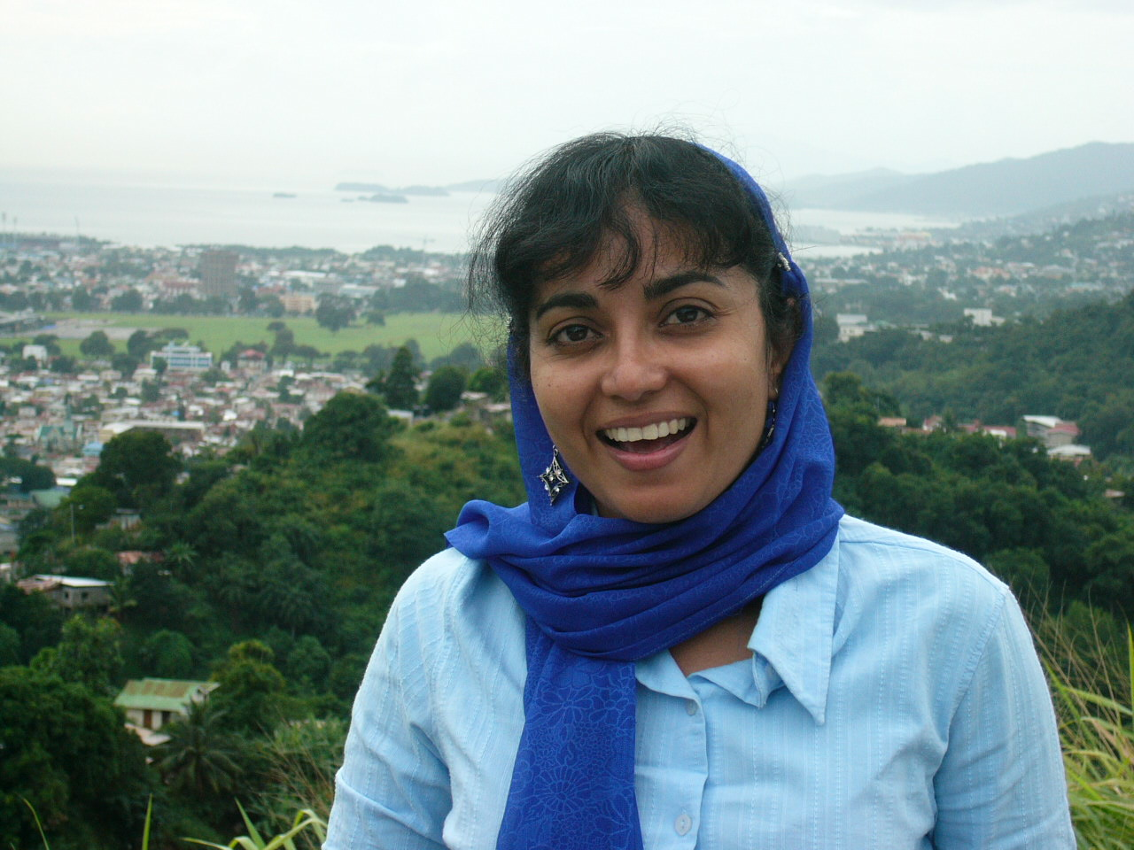
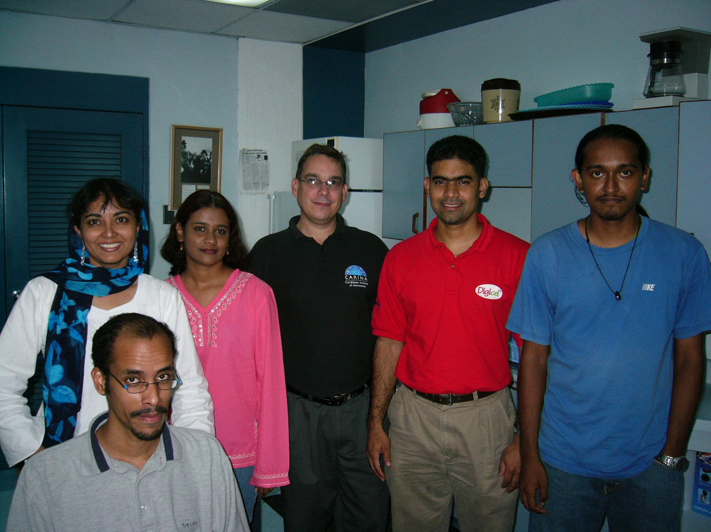

Left: Dr Shirin Haque, Trinidad’s only professional astronomer, with Port of Sapin in the background. Right: Shirin Haque (rear left) Graham Rostant (centre) and four astronomy students at UWI.

director of Tuorla Observatory, is interested in optical monitoring of the quasar OJ287 and he has visited UWI in Trinidad to promote this collaboration. A 40-cm Schmidt-Cassegrain Meade telescope with a CCD camera is mounted on the roof of the department at the St Augustine campus. This instrument is used for monitoring OJ287. The telescope is computer-controlled and the CCD images are reduced using IRAF software.

Shirin Haque is teaching one undergraduate course in astrophysics, comprising 13 lectures. This overall course is entitled ‘Optics and Astronomy’ also covers aspects of optics (taught by other staff). This is a level II course and the enrolment is typically about 30, but the number is growing. It is part of the major in physics. The course highlights all aspects of astronomy from the solar system to the Sun, stars, galaxies and cosmology. The students are making use of Gettysburg College’s CLEA software for practical work in astronomy.

There are currently 64 students who expect to graduate with the BSc majoring in physics in 2006. This number is increasing, and numbers for 2005-06 are a record. This is in contrast to the other campuses of UWI in Jamaica and Barbados, where physics is not so strong and astronomy is not taught at all.

There are three students doing MPhil degrees in astronomy. Two of these are interested in quasar photometry, and one recently enrolled student is working on aspects of astrobiology. I was also able to meet some of the senior undergraduate students interested in astronomy. One of these is Derick Cornwall, who is making extensive use of the roof-top telescope and astronomy laboratory at the department. Derick is one of the founders of CARINA (see below). I was impressed with the calibre of all these students. Derick Cornwall went to NOT, the Nordic Optical Telescope in La Palma in January 2005. His observing run was part of the collaboration with Finland mentioned above.

Clearly the support of astronomy at UWI in Trinidad is still quite tenuous. That it is thriving is a tribute to the enthusiasm and energy of Shirin Haque. A recent departmental review in November 2005 recommended increasing staffing levels in physics from the current ten academics; hopefully any future increase would include at least one more position for an astronomer. In addition the review recommended that a postdoctoral position in astronomy be established.

The climate is not wonderful for optical astronomy, and the extended rainy season makes observing difficult between June and October. In addition there are no high altitude sites suitable for a larger telescope in the future. However, optical astronomy with small telescopes is an excellent and inexpensive way of training students with hands-on experience of doing research. Theoretical astronomy is widely perceived to be less expensive, which may be true if large computing facilities are not required. There is no radio-astronomy at present in Trinidad, but a future VLBI collaboration with astronomers in the USA or Puerto Rico could be an interesting goal to pursue.

4. Programme of visit and lectures given

I arrived in Trinidad on Sunday December 4, and my week-long visit included radio and television interviews with Shirin Haque, visiting the Department of Physics at UWI and meeting staff and astronomy students there, meeting members of CARINA (the Caribbean Institute of Astronomy), and visiting Trinidad’s National Science Centre. On the Thursday evening I gave a public lecture at UWI on “Time and Evolution in the Cosmos” with about 200 people present, and on the Friday there was a departmental seminar on “The Search for planets beyond our solar system”.

I also gave a talk on the work of IAU Commission 46 to members of CARINA on Friday and then I had the pleasure of visiting the observatory of the Trinidad and Tobago Astronomical Society that evening. The observatory with 30-cm telescope was established by a UNESCO grant in 2003. I was also a guest at the society’s end-of-year dinner at Mt St Benedict, a superb monastery on the hills above the Port of Spain. I gave a short talk on astronomy in New Zealand to the fifty or more members of the society who were present after dinner.

On the Saturday (10 December) I flew with Derick Cornwall to the nearby island of Tobago, and visited the SEAS (Sea Earth and Sky) Observatory. It is a privately owned observatory with a 30-cm Meade telescope on a superb hill-top site overlooking the Caribbean Sea; access to it is generously granted to UWI astronomers by the owner.

5. CARINA

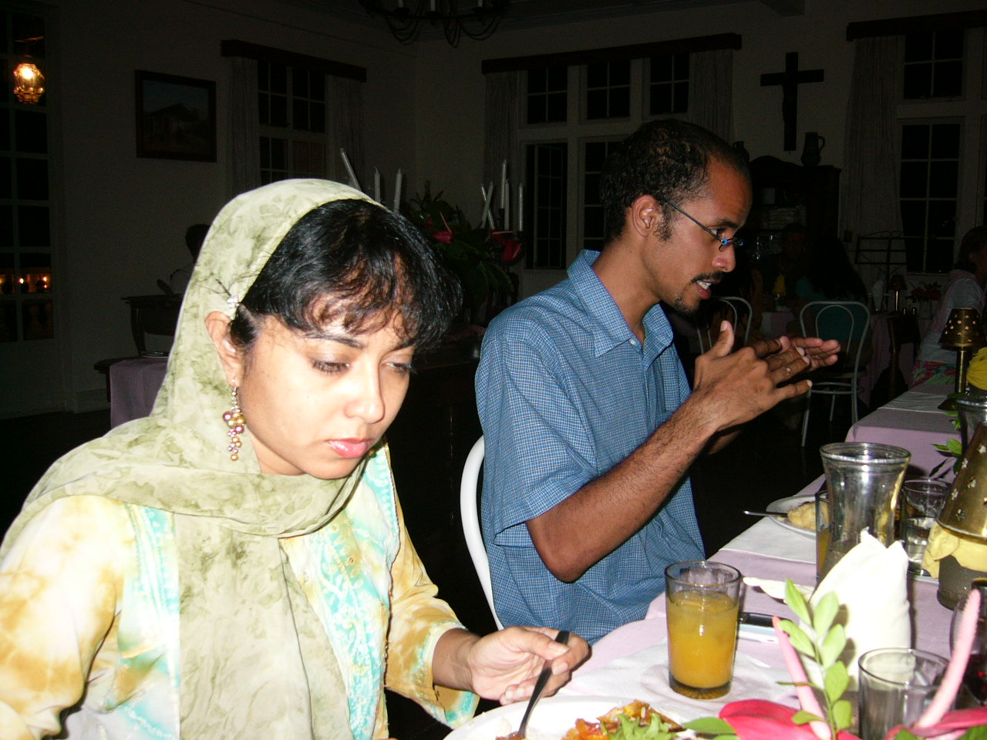
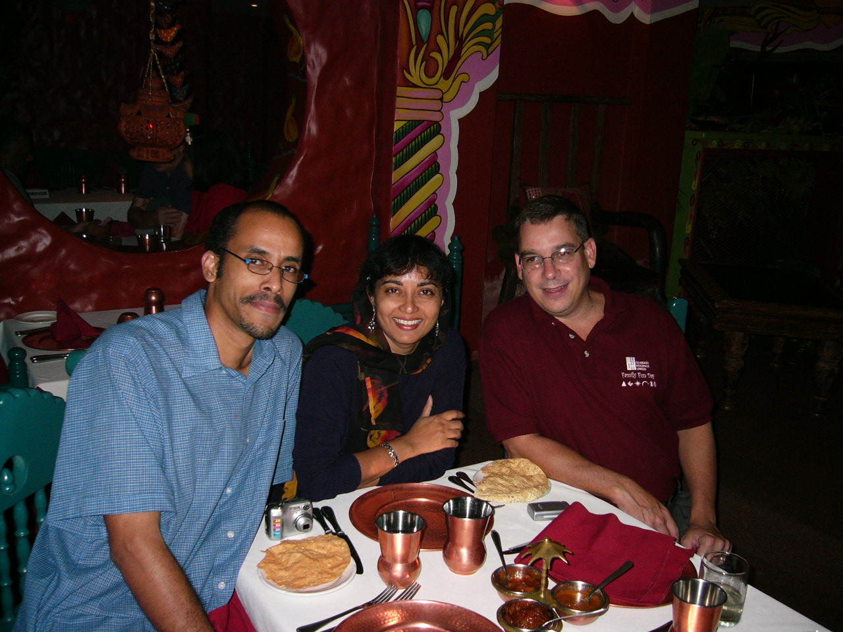
CARINA is the Caribbean Institute of Astronomy. It was founded in 2002 and is described as a non-profit, educational and scientific organization dedicated to the growth and development of astronomy within the Caribbean region. CARINA does not have members in the style of an astronomical society; instead there is the Board of Directors which includes three of the founders of CARINA, namely Shirin Haque, Derick Cornwall and Graham Rostant (the last named is a businessman who runs an advertising company in the Port of Spain).

Left: Shirin Haque and astronomy student, Derick Cornwall
Right: The three founders of CARINA, Derick Cornwall, Shirin Haque and Graham Rostant

CARINA is a collaborative effort among professional astronomers, astronomy enthusiasts, educators and members of the business community. The Department of Physics at UWI works closely with CARINA.

For the small island nations of the Caribbean, UWI-CARINA may represent one of the few centres where research astronomy has any presence at all. However larger centres for professional astronomy in the region are to be found in Venezuela, Colombia, Cuba and of course in Mexico and the USA. Trinidadian astronomers naturally look to the USA for support for their science, or even beyond the Caribbean-North American region, as the collaboration with Finland illustrates. Political and language barriers have hampered any collaboration with other centres of astronomy in the Caribbean. In this sense, Trinidad can be seen as quite an isolated country, with barriers coming from language, politics, ethnic differences or economic differences in the case of most of its immediate neighbours.

It remains to be seen if these factors will continue to hamper the international aims of CARINA in the future. However, the aim of developing further astronomy education and research within Trinidad and Tobago would seem to be more easily realizable.

6. Astronomy in Jamaica and Barbados

I have no first-hand knowledge of astronomy in the neighbouring Caribbean countries of Jamaica or Barbados. The comments here are based on what I was told while in Trinidad, notably by Shirin Haque, who had recently visited the UWI campus in Jamaica.

The Department of Physics at UWI-Jamaica has a 21-inch (53-cm) telescope, which is therefore larger than any in Trinidad. Apparently there are no astronomers there at present to use it. The astronomical society in Jamaica has two telescopes, of 20-cm and 30-cm aperture.

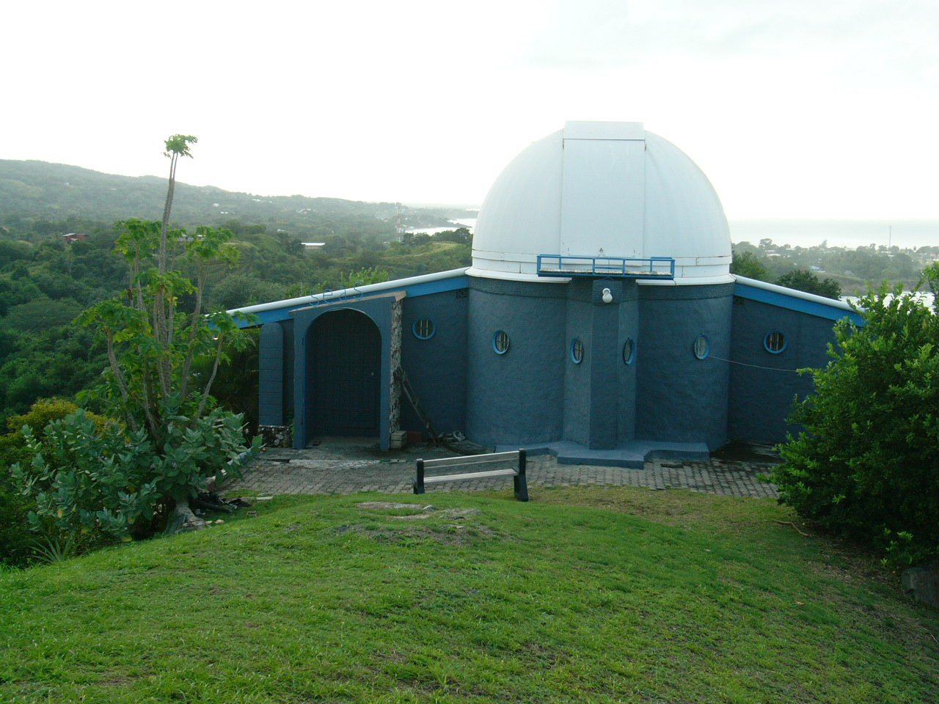
In Barbados, the third UWI campus has no astronomy, but physics and electronics are taught in the Physics Department there. There is an active astronomical society in Barbados with some 60 members, and it will celebrate its fiftieth anniversary in 2006.

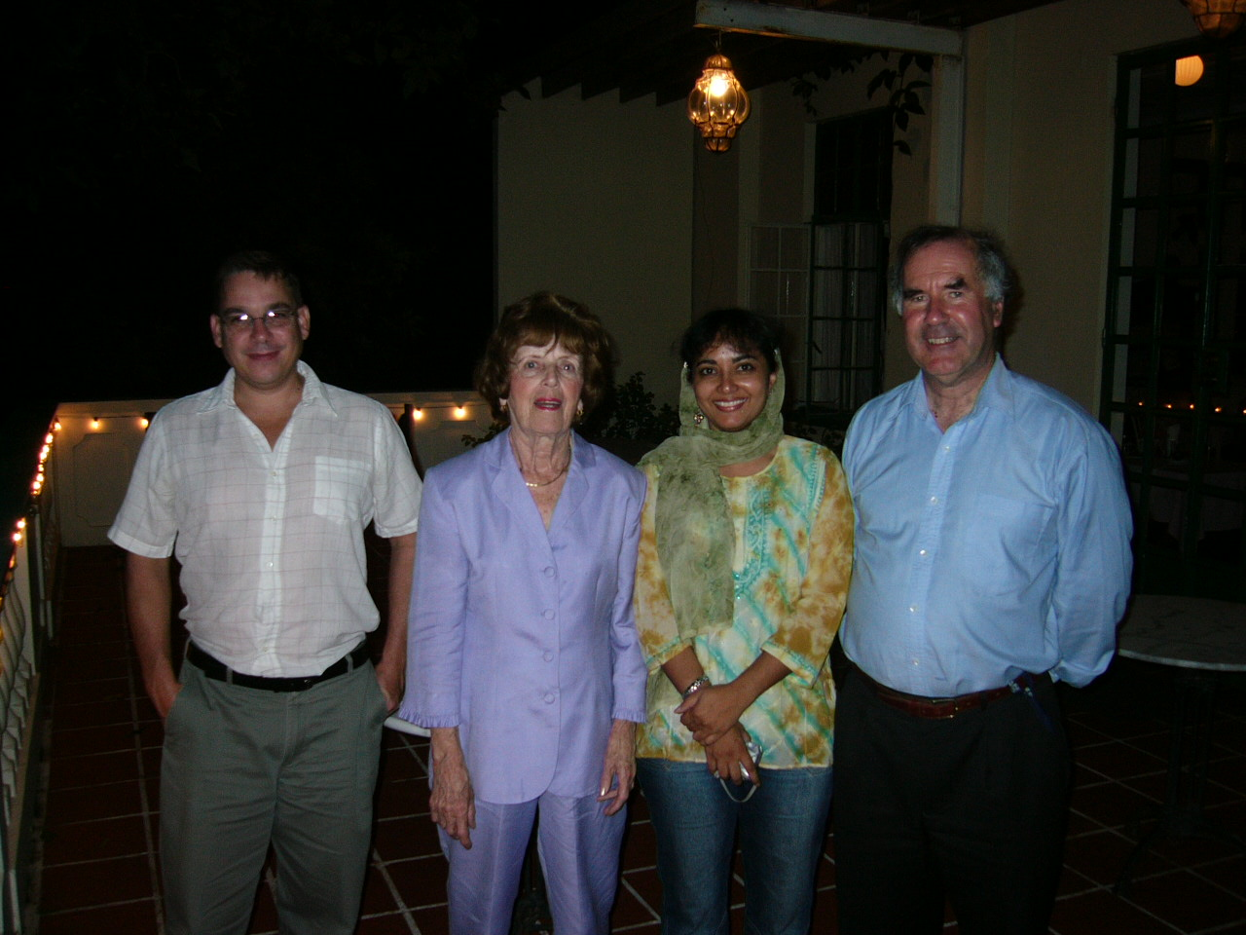
Left: Graham Rostant, Dr Maura Imbert (president of the Trinidad and Tobago Astronomical Society), Shirin Haque and the author. Right: The SEAS Observatory in Tobago, which houses a 30-cm Meade telescope.

7. Trinidad and the IAU: recommendations for the future support of astronomy

The single main problem facing astronomy in Trinidad is the small number of astronomers. The single permanent professional astronomer, Dr Shirin Haque, at UWI is also the Acting Head of the Department of Physics, so much of her time is now taken up with administrative duties. She is supported by several able and enthusiastic students, but this hardly constitutes a critical mass of astronomers. This problem was recognized in a recent review of the Department of Physics (the review took place in the week prior to my visit), and the preliminary report of the review committee recommended that at least one more position be established in astronomy, as well as the appointment of a postdoctoral fellow in astronomy.

Apart from that obvious need, the way forwards may well lie in international collaboration. The thriving collaboration with Tuorla Observatory in Finland is a welcome development. One of the MPhil students has spent a week in 2004 at the Sonneberg Observatory in Germany digitizing photographic plates for quasar photometry: this is another example of recent international exposure for Trinidad astronomers.
In 2005 the International School for Young Astronomers in Puebla, Mexico, there were three Trinidadian student participants from UWI. This was further welcome exposure.

In short, what Trinidad needs is more staff astronomers at UWI, more funding for astronomy research and more international contacts and collaborations, such as through participation in conferences, young astronomer schools or exchange visits for research collaborations. All these things are already happening to some extent, but if astronomy in Trinidad is to survive it must grow, and these types of activities need to be maintained or increased.

Until astronomy has a stronger professional presence in Trinidad, it is probably unrealistic to expect this small but strongly developing country to join the International Astronomical Union. However, that situation could change if UWI can expand its staffing complement to two or three astronomers in the future. Meanwhile, it is hoped that Shirin Haque can become an individual member of the IAU, and thereby promote some of the aims of increased international contacts that would be so beneficial for her small group.

My overall impression of astronomy in Trinidad, both at UWI and the closely associated CARINA organization, is that here is a small but very enthusiastic group of people with some very able students under their wing. With encouragement and support from the IAU, astronomy could grow here and have an excellent future.

Acknowledgement

I am grateful to the Erskine Fund of the University of Canterbury, New Zealand, for a grant which supported my travel and stay in Trinidad. I thank Shirin Haque for all the detailed arrangements she made for my visit.

John Hearnshaw
Chairperson of the Program Group for the World-wide Development of Astronomy
within IAU Commission 46 (Astronomy Teaching and Development).

